Sprint 1 - Endurance

October 10, 2019

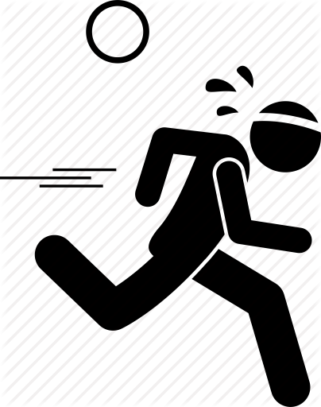**Table of Contents**

**1.** **EXECUTIVE SUMMARY 3**

1.1 Project Overview 3

1.2 Purpose and Scope of this Specification 3

**2.** **PRODUCT/SERVICE DESCRIPTION 3**

2.1 Product Context 3

2.2 User Characteristics 3

2.3 Assumptions 3

2.4 Constraints 3

2.5 Dependencies 4

**3.** **REQUIREMENTS 4**

3.1 Functional Requirements 5

3.2 Security 5

*3.2.1* *Protection 5*

*3.2.2* *Authorization and Authentication 6*

3.3 Portability 6

**4.** **REQUIREMENTS CONFIRMATION/STAKEHOLDER SIGN-OFF 6**

**5.** **SYSTEM DESIGN 6**

5.1 Algorithm 6

5.2 System Flow 6

5.3 Software 6

5.4 Hardware 6

5.5 Test Plan 7

5.6 Task List/Gantt Chart 7

5.7 Staffing Plan 7

# Executive Summary

## *Project Overview*

* This program will allow the Sphero robot to complete a loop around a classroom.

## *Purpose and Scope of this Specification*

* This project’s purpose is to serve as an assignment and assessment of our skills to coordinate and work together in order to successfully program a robot to traverse the four corners of a classroom.

# Product/Service Description

## *Product Context*

* This product is a project for our CS-104 class
* The product is dependent on the code and bluetooth connection to a device

## *User Characteristics*

* This program is to be used exclusively by the members of the group and to be graded by Professor Eckert.

## *Assumptions*

* Operation room is available.
* Availability of the utilized product.
* Determined factors of a successful operation (written algorithm, established procedure)
* Adequate skillset of programmer operating the required device.
* 100% charge present in device for optimal functionality.
* Product is tested for faults in algorithm.

## *Constraints*

* The robot’s battery life is quite limited.
* The robot’s charging time is quite lengthy
* The only area where the robot can be tested is in Howard 208

## *Dependencies*:

* The code must function correctly.

# Requirements

|  |  |  |  |  |  |
| --- | --- | --- | --- | --- | --- |
| **Req#** | **Requirement** | **Comments** | **Priority** | **Date Rvwd** | **SME Reviewed / Approved** |
| END - 1 | The robot must pass all corners of the classroom and end at the original starting area. | N/A | 1 | 10/25 | Approved |
| END - 2 | The robot should stay on course and remain on the track. | N/A | 1 | 10/25 | Approved |
| END - 3 | The robot must glow at the beginning and end of the program. | N/A | 1 | 10/26 | Approved |

## 

# System Design

This section will provide all details concerning the technical design, staffing, coding, and testing the system

## *Algorithm*

* Connect your device to the robot, using Sphero software.
* Place your robot at the start of the track.
* Orient your robot correctly.
* Execute program.
  + Roll in a straight line for __ feet towards the opposite corner of the room
  + Stop.
  + Rotate __ degrees
  + Roll in a straight line for __ feet towards the short end of the room.
  + Repeat until robot travels around room.
  + Stop at the start.

## *System Flow*

(flowchart goes here)

## *Software*

* This robot is coded in JavaScript using the Sphero program’s block feature.

## *Hardware*

* Our smartphones and laptops contain the coding software.
* The robot is a Sphero robot.

## *Test Plan*

|  |  |  |  |  |  |
| --- | --- | --- | --- | --- | --- |
| **Reason for Test Case** | **Test Date** | **Expected Output** | **Observed Output** | **Staff Name** | **Pass/Fail** |
| Experimenting with Code | 10/23 | Get a grasp on how the robot functions | Understood the robot’s movements | Adriel | Pass |
|  |  |  |  |  |  |

## *Task List/Gantt Chart*

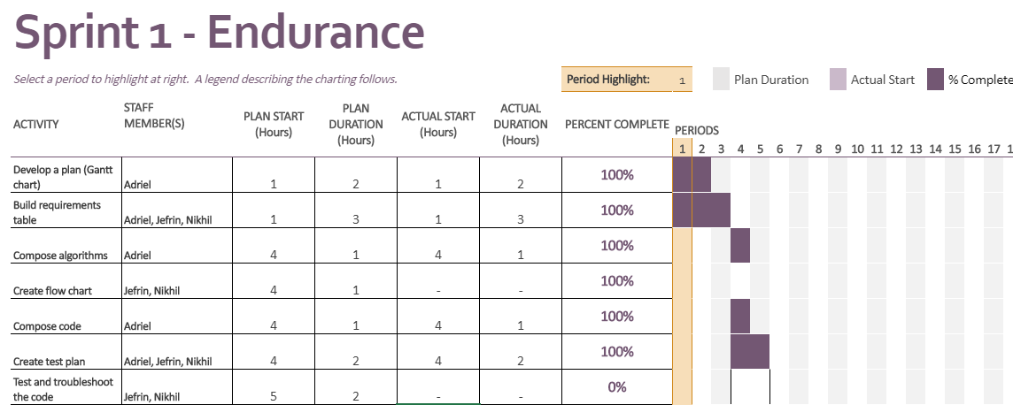

## *Staffing Plan*

Insert a chart/table that depicts the roles and responsibilities of each team member that worked on this project

|  |  |  |
| --- | --- | --- |
| **Name** | **Role** | **Responsibility** |
| Adriel | Programmer, Planner | * Write requirements * Write the code * Develop Gantt Chart |
| Jefrin | Tester, Writing | * Test robot |
| Nikhil | Tester, Writing | * Troubleshoot robot |